Setting Print Margins for Shropshire FIT ICE

Open screening ICE in Edge with the following URL, this should open in compatibility mode:
https://gatesheadscreeningservices.ghnt.nhs.uk/icedesktop/
Right click on the desktop and select ‘print preview’
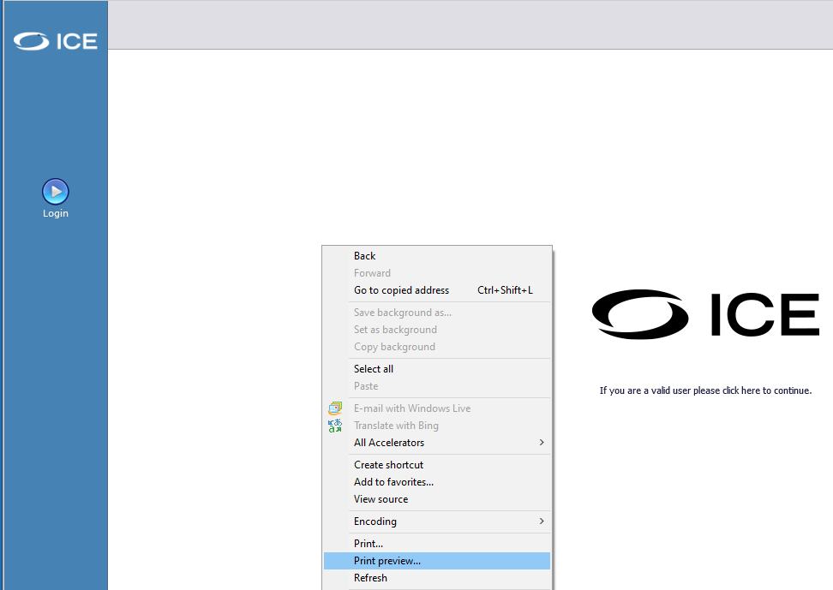
From the toolbar click on page setup to display the page setup dialogue box. Ensure the margins are set to 19.05.
