Troubleshooting a Zebra ICE Label Printer
A quick list of things to check to make sure your printer is running correctly:
- Your printer is named ‘ICE Label Printer’ in your printer list.
- The ICE Label Printer is not set as the default printer.
- There are no documents blocking your print queue.
- The correct ScriptX is installed on your PC.
- The USB cable is plugged into the back of the printer and the PC.
- No labels are stuck to the roller inside the lid of the printer.
- The small yellow sensor is aligned to the small arrow underneath the labels.
- The printer lid is closed properly.

Recalibrating your printer
This usually resolves any issues with the printer reeling out labels. Hold down the X and the pause button together, this should spit out about 2/3 labels. This may need done a few times for the printer to recalibrate correctly. If the orange pause light is on after recalibrating, just press the pause button once to take it out of pause mode then try to reprint a sticker.
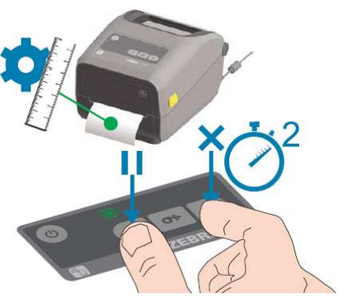

Checking the name of your printer
In the search bar at the bottom left of your screen, type ‘printers and scanners’. This will bring up a list of printers connected to your PC. In this list you should find an ‘ICE Label Printer’. If there is a printer named ‘ZDesignerZD410’ or anything similar, this will need to be renamed to ICE Label Printer. You or someone with admin rights can do this by clicking on the ZDesigner, then clicking on Manage, Printer Properties, and changing the name in the box.
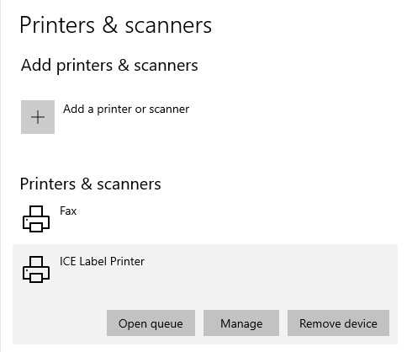
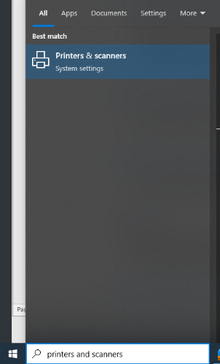

Setting a default printer
The ICE label printer must not be set as the default printer, as this will allow A4 documents to be printed and this can block up the print queue. Please set any regular printer to the default by clicking into it, clicking Manage and setting as default.
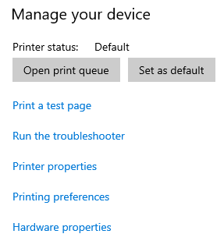

Check your print queue
You can check the print queue of your Zebra by clicking the ICE Label Printer and clicking ‘open queue’
You can delete anything queued by selecting them and pressing delete on your keyboard.
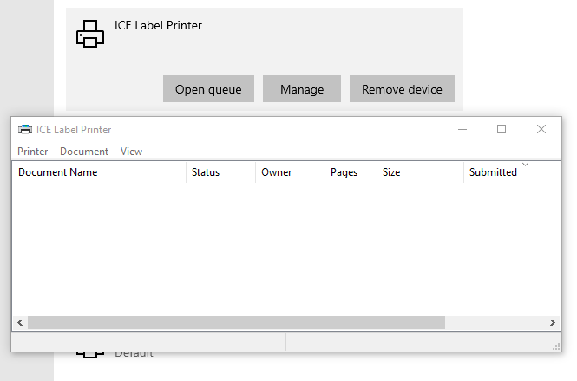

ScriptX
You can download the correct ScriptX here. You will need admin rights to the computer to install https://support.meadroid.com/Downloads/ScriptXAddon/User

Checking the yellow sensor
The sensor must be positioned in the middle of the printer, lining up with the small arrow on the grey area, as per the screenshot below. You will need to recalibrate the printer once this has been moved into position (see above)
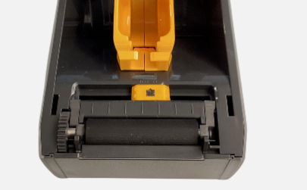

Hard reset your printer
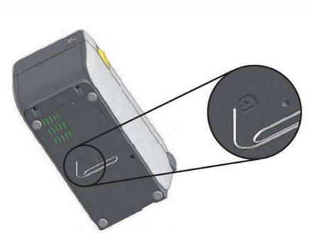
If necessary, try resetting the printer by putting a paper clip in the underneath of the printer as per the picture below for around 10 seconds. This may take a few attempts. You will know it has reset when 4-5 stickers of printer config have been printed

