ICE Order Communications Staff Training Manual

Pathology Users

Table of Contents
1. Overview of the ICE system………………………3

2. Patient Search……………………………………….4

3. Requesting……………………………………………7

4. Reporting ……………………………………………11

5. Contacts and further information ……………….14
1. Overview

ICE is the system used within Gateshead Trust for ordering Pathology, Radiology and Endoscopy Tests and Viewing Patient Results. Access to South Tyneside and Sunderland ICE is used only by GP Practices.

Gateshead Screening Service have a separate ICE system for requesting Primary HPV Test and this is accessed by Trusts, Prisons, Community Clinics and GP Practices throughout the Northern Regional Hub.

This guide is designed to show users how to Search for a patient, Request Pathology Tests and View Reports. Contacts and Further Support is included at the end.

ICE Access

The Gateshead ICE system is accessed at the GP Practice using the clinical system EMIS Web, through an interop link from the patient record. Access to ICE at the Trust is through the Medway PAS interop link from the patient record. The Trust can also access ICE as Standalone.

South Tyneside ICE is accessed at the GP Practice using the clinical system EMIS Web through an interop link from the patient record.

Sunderland ICE is accessed from the GP Practice using the clinical system through an interop link from the patient record. Sunderland Practices use two clinical systems: EMIS Web and SystmOne.

Gateshead Screening Service Users can access ICE as standalone from Trust locations, Prisons, Sexual Health Clinics and Community Centres or via an interop link from GP Practices. GP Practices throughout the Northern Hub use EMIS Web and SystmOne.

GP requests for access are received from the Practice using an ICE New User access request form. There is a separate request form for each Trust. The level of access required by each user can be selected on this form.

Trust requests for access to ICE can also be made on an ICE User Request for Access form. Please note that there is a separate request form for each Trust and the level of access required can be indicated on this form.

Access to Gateshead Screening Service ICE is on one New User Access Request Form.

Security of access is managed by an individual username and also a password; non GP Users will be forced to change their password every 30 days. The request forms should be emailed as follows:

Sunderland GPs Gateshead Pathology Centre
Email: ghnt.pathsupport@nhs.net

Gateshead Queen Elizabeth Hospital IT Service Desk
Email: ghnt.itservicedesk@nhs.net
South Tyneside South Tyneside Hospital, Information Department
Email: IceRequests@stft.nhs.uk

Gateshead Screening Email: ghnt.pathsupport@nhs.net
Service

Standalone Access

The ICE Standalone Login Screen is shown below. A unique username and password will be issued to each user by email.

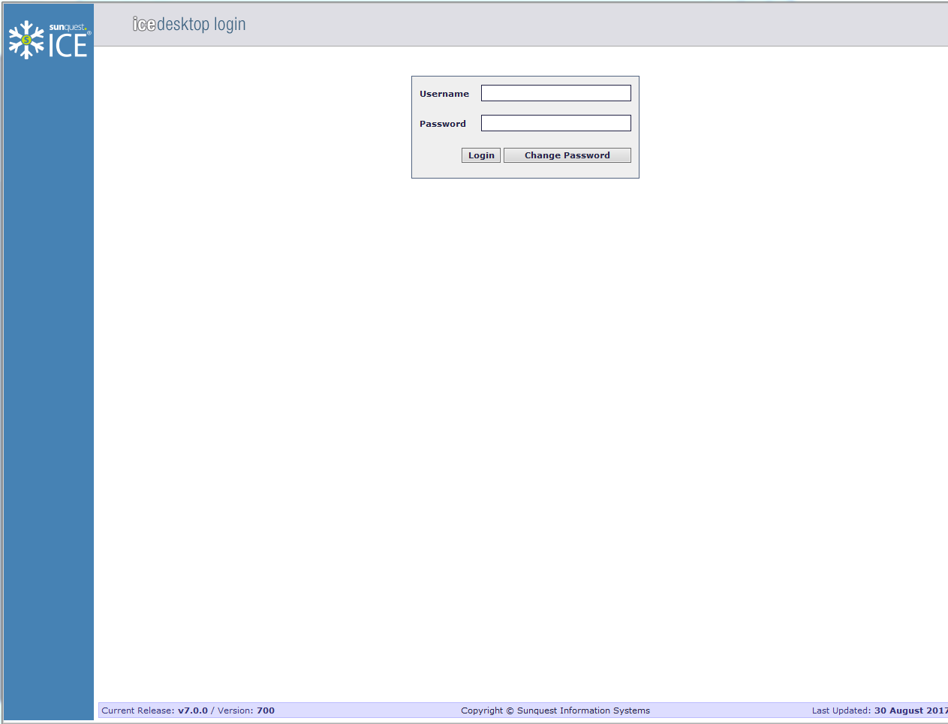
2. Patient Search – Standalone ICE only

Once successfully logged onto ICE in the Standalone version you will be presented with the Patient Search Screen. (Please note that if accessing ICE from an interop link you will already be in the patient record and will not get this screen.)

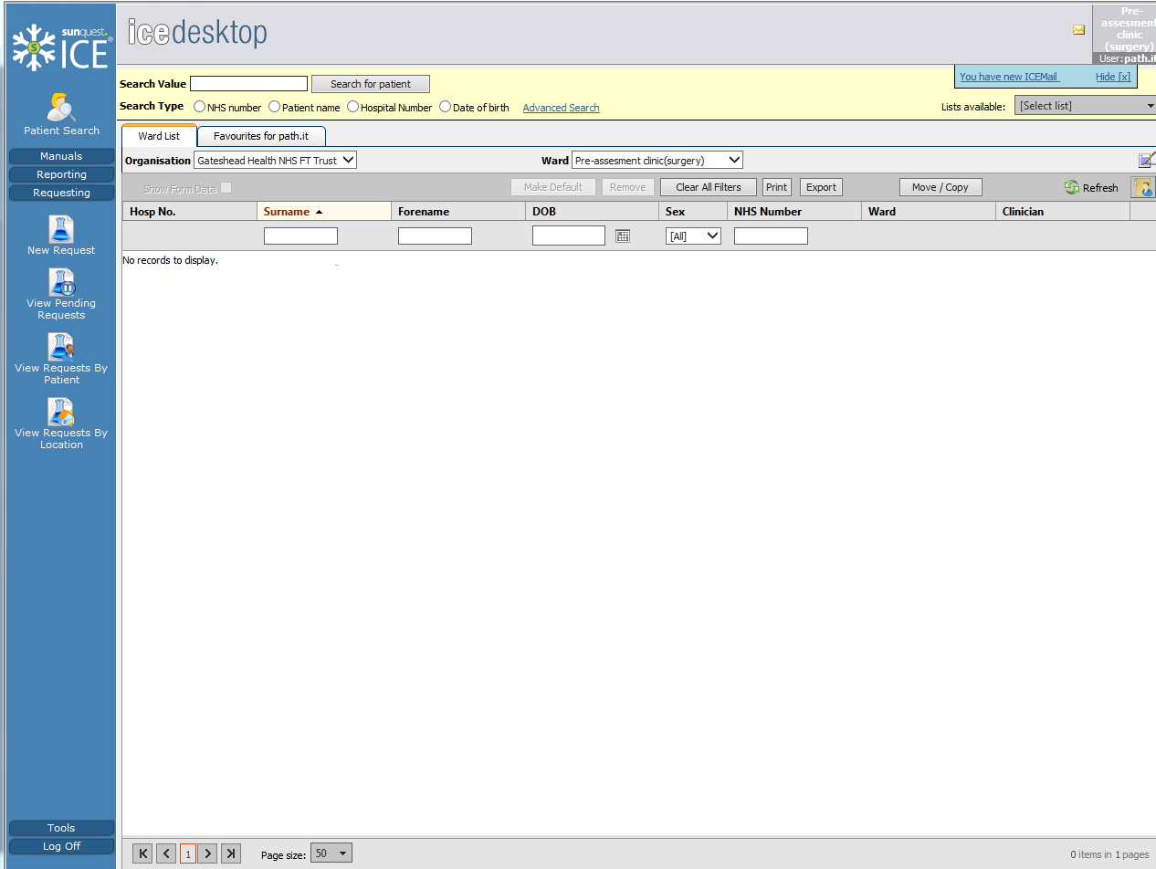

You can search for a patient by Hospital Number, NHS Number, Patient Name or Date of Birth.

Enter the Search value for the patient and click search for patient.

Your search will return the patient’s matching the search value entered. See example below of a returned search when entering surname, forename “testing, Robert”

(Trust users only have access to a Ward List on ICE; which lists all the current patients admitted to a particular ward location. You can select the patient from this Ward list by clicking onto the patient without the need search.)

Search Screen showing returned results:
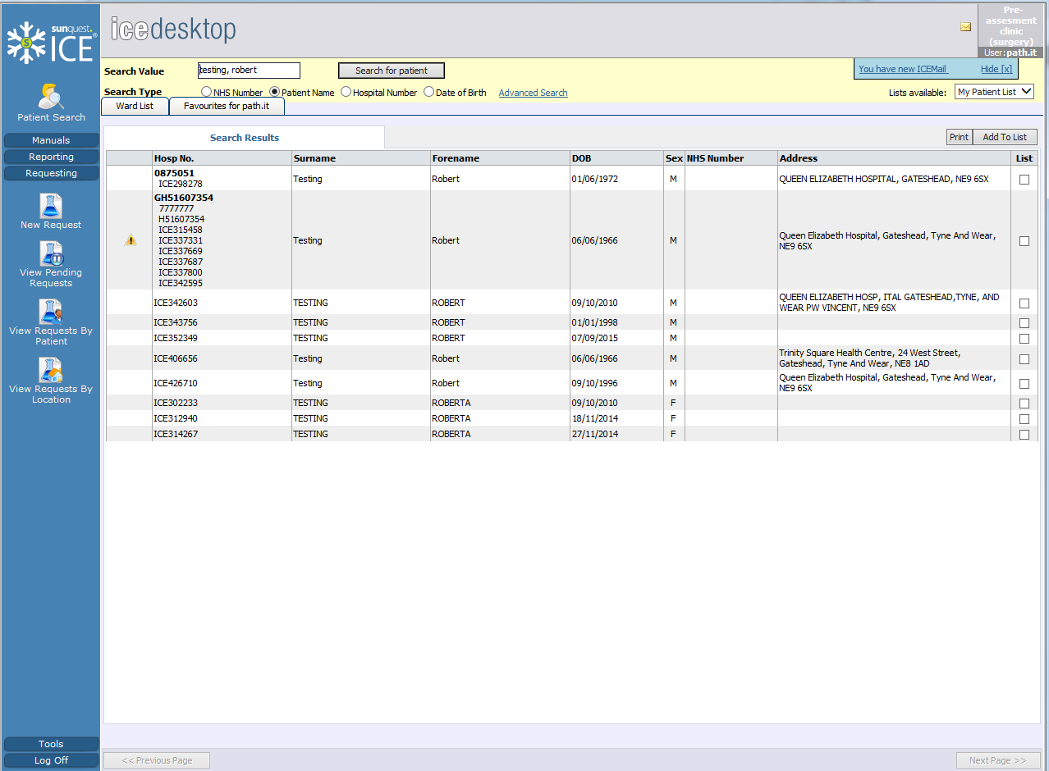
Click onto the line of the patient to select. The patient’s details will appear at the top of the page indicating your selection.

You can proceed onto requesting or reporting using the blue panel down the left hand side of the page.
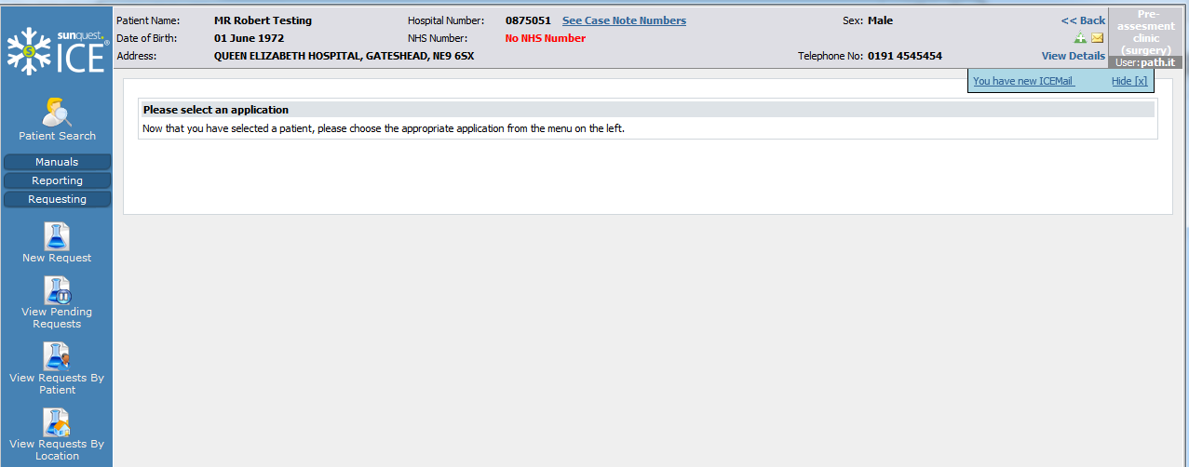

Please note that if using the interop to access ICE, from a GP Practice or a PAS system, the blue panel will be replaced by a Services Menu. Hover over the Services menu to expand the options available; you can navigate between requesting and report functions.
See example below of Services menu:
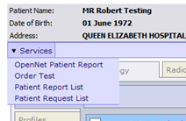
3. Requesting
Once you have selected the patient you require, click onto the Requesting Panel from within the blue panel down the left of the screen and select “New Request”. If using the interop select “Order Test” from the Services menu.

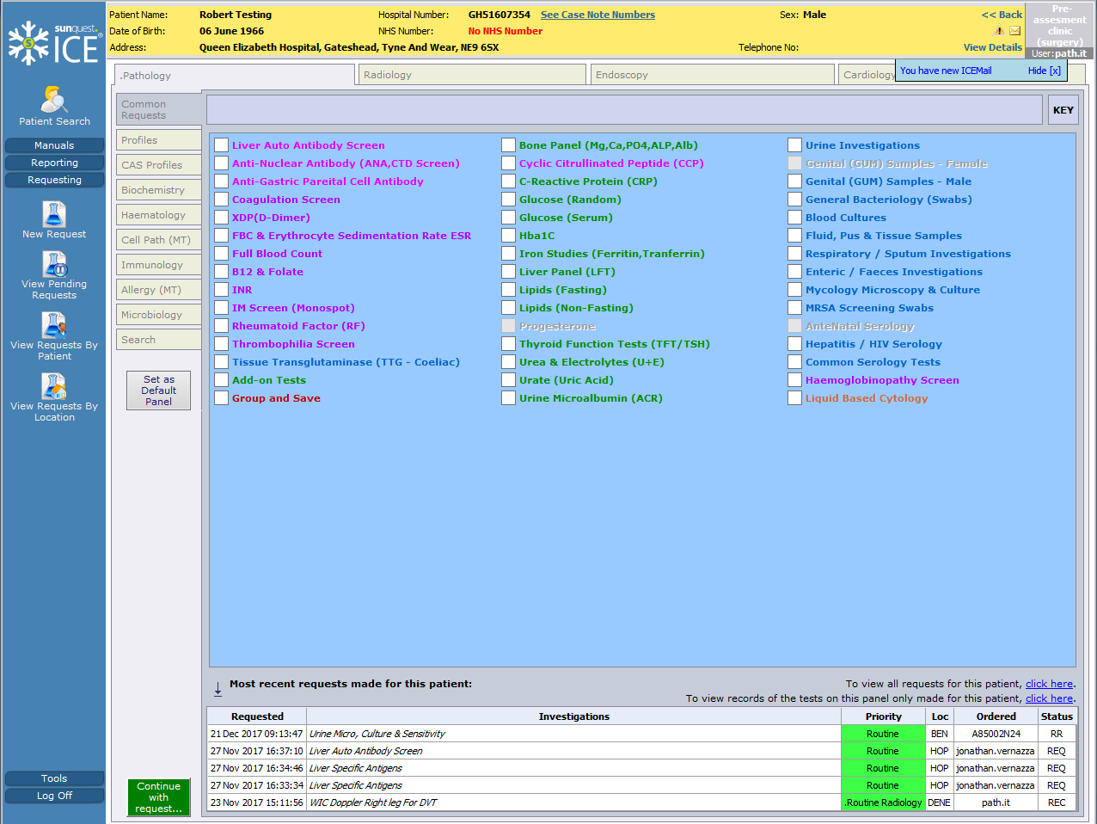

Selecting New Request will default to the Common Request screen. You can change your default by clicking onto the “Set as Default Panel” button on the left of the screen – you must be in the requesting page you wish to set as default first before clicking this button. ICE will then save this page as your default when you next select New Request.

Click onto the white check box next to a test to select.

If you cannot find the test you are looking for on the Common Request screen, drill down further by selecting a discipline from the left hand side of the screen to display additional tests available, for example: Biochemistry, Haematology and Microbiology.

You can search for a test using the Search box; this option is at the bottom of the list of disciplines on the left. Type in full or part of the test name you are looking for and click search.

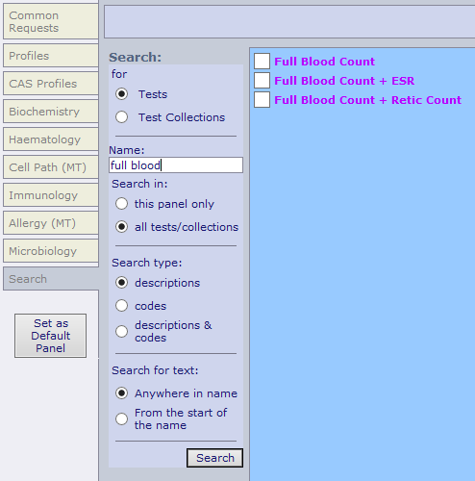

Continue through the screens, selecting the tests you require. Please note that you can order across Pathology, Radiology and Endoscopy on the same request.

Some tests when selected will prompt a series of questions known as rules; these have been configured by the lab to gather important clinical detail regarding the patient and the rules must be answered to allow for the request to continue.

Click onto the green “Continue with request.” button at the bottom left of the screen.

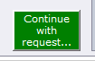

You will then be taken to the General/Order Details screen (shown below).

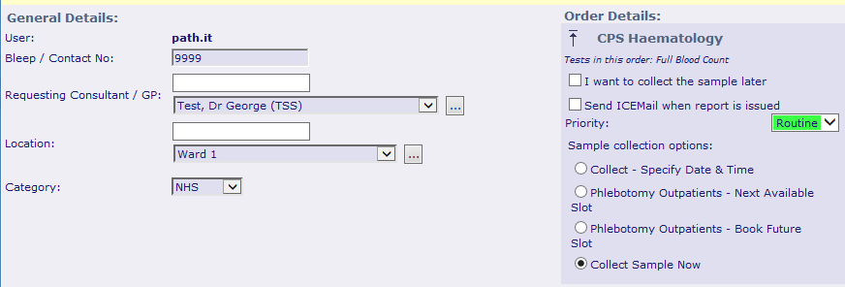

General Details

Bleep No. – used by the lab to contact you if required
Requesting Consultant/GP/Location – the correct Clinician and Location is required at this stage to ensure results are returned correctly.

Order Details

I want to collect sample later – Check this box if you would like to collect the sample at a later date. This is ideal for a GP Practice if unsure when a patient will return for their bloods to be taken or when they will drop off a sample. This option postpones the order which will remain in ICE and avoid the order being cancelled within the lab system. Select Print a postponed request summary for this order – this will print an A4 sheet which can be given to the patient as a reminder and to take along with them for their bloods to be collected. This summary will also help the phlebotomist/nurse to identify which bloods are to be taken.
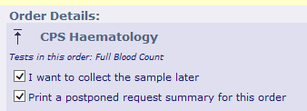

Send an ICEMail when the report is issued – Checking this box to receive an internal ICE Mail notification when the report is issues.

Priority – Choose the priority of the request.

Sample Collection Options

These options may differ slightly depending on whether using ICE at a GP Practice or a Trust location:

o Collect Sample Now – Request form prints with date and time included (Order details will sent to Lab System from ICE)
o Collect – Insert Date and Time - request prints without date and time, allowing this to be added at a later date manually. (Order details will be sent to the lab system from ICE)
o Phlebotomy Outpatients – book next available slot (When you click to accept the request the next available time slot will be allocated automatically)
o Phlebotomy Outpatients – book future slot (Allows you to select a convenient future date/time to suit the patient from a calendar.)

Once all of this information is complete, click Accept Request at the bottom of the screen. If your PC is configured to print to an ICE Label Printer (Zebra), the labels will print out automatically. If your PC is linked to an A4 printer you will get a Print box to select the printer:

- A request form will print out for “Collect Sample Now” and “Collect –insert date and time” collection options. Note the print box will appear several times if ordering a number of tests.

- Nothing will print out when Phlebotomy outpatients collection option is selected.

- A plain A4 order summary sheet will print out for postponed orders, providing a postponed summary has been requested.

Ensure you select the correct printer and that the correct stationary has been loaded into the printer?

4 Reporting

Once you have located your patient, click on the reporting panel to the left of the screen.
Within Standalone ICE you can view individual patient reports and also a group of reports using “View Ward Reports” and “Unfiled Reports.”

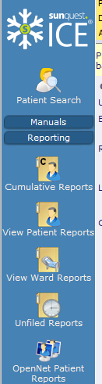

If using an interop connection, select “Patient Report List” from the Services Menu”. As you are using the interop link from the patient record within the clinical system, the only option available is to view an individual patient report.

Patient Reports / Patient Report List

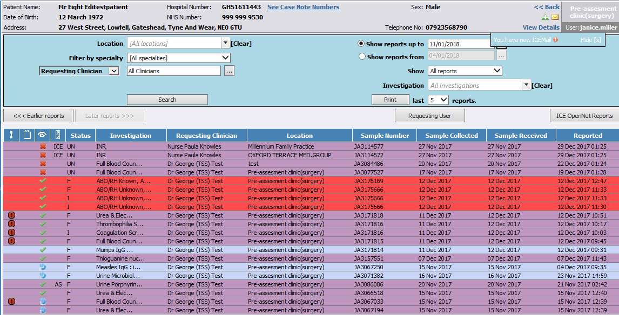

The patient report screen is shown above. Reports are coloured according to their discipline

Column 1 - Abnormal results are indicated with a red exclamation mark
Column 2 – will indicate if a note has been added manually by a user
Column 3 – shows viewed status of report. Red Cross = unviewed, Green tick = who viewed report last, Blue circle = report updated since last viewed.
Column 4 – Filing status (filing confirms report acknowledged and acted upon)
Column 5 – Report status. For ex: Final report =F, Interim Report = I
Column 6 – Investigation description
Column 7 – Requesting Clinician/User
Column 8 – Location Sample Originated
Column 9 – Sample Number
Column 10 to 12 – Sample Collected/Received/Reported Dates

Click onto a report to view it. There are various options available at the top of the screen, these are explained below.

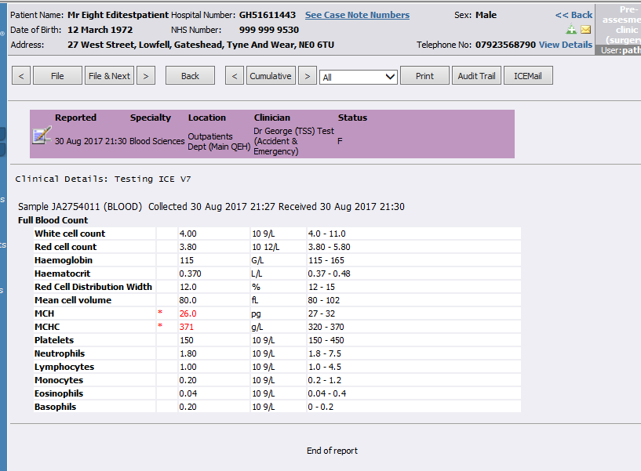

- Use the forward and back arrows to scroll through reports for the patient.
- File button is confirming the report has been actioned and acknowledged. The Date and time is logged in ICE when a report is filed.
- Cumulative view will allow you to view result trends and graphs.
- You can print the report.
- ICEMail – this will send an internal Mail to another ICE User and this functionality is available within every report on ICE.
- An Audit Trail is held in ICE of each time a report is viewed

Unfiled Reports (Standalone ICE Only)

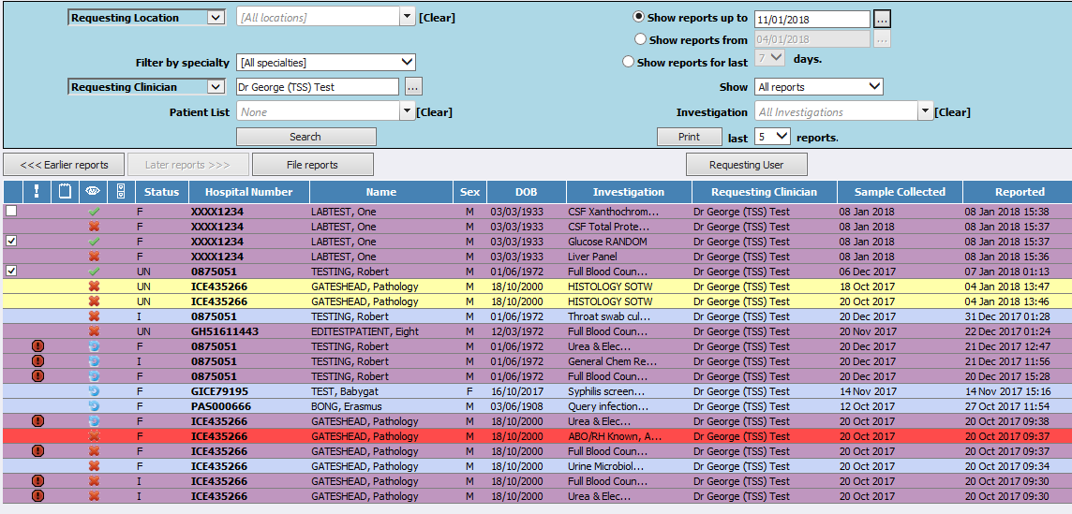

This option allows a user to bulk file reports. You can define your search criteria in the top section of the page. In the example above we have selected Dr Test’s reports. When a report has been viewed a white check box will appear alongside the report. When you check a white box this activates “File Reports” box, allowing a user to file several reports at once. Once a report has been filed it will drop off this view.

Ward Reports (Standalone ICE Only)

This is the same report view as Unfiled reports with the same options at the top of the screen to define your search. The only difference is that this view will include reports which have been filed as well as unfiled.

5 Contacts and further information

Sunderland GPs Pathology IT, Queen Elizabeth Hospital 0191 445 6504
Email: ghnt.pathsupport@nhs.net
Gateshead Trust/GP IT Service Desk, Queen Elizabeth Hospital 0191 445 2397
Email: ghnt.itservicedesk@nhs.net
South Tyneside Trust/GP Information Team, South Tyneside Hospital 0191 4041000
Email: IceRequests@stft.nhs.uk

Training is available online for Gateshead Trust users.
Intranet, Info Services, Systems, ICE Order communications, Training packages,

http://staffzone.xghnt.nhs.uk/learning/e-learning-material/systems/ice-order-communications.php

